Autumn 07 | Flash Media Server

What is Flash Media Server?
Flash media server is a program that you can install on your server. Normally speaking the server, for instance using Apache, deals with the translation and processing of PHP. De server can also store internet pages so that you can see via your browser with http. You should view the media server in the same way. It is a program which you install on your server and which allows you to can retrieve media streaming (video, sound, text) via your browser.
A well-known website that used media server fabchannel. Youtube uses the Flash player to show video, but has its own server system to store and stream all videos. For more products see the showcase at Adobe.
When you have installed this application on the server, you access it via your browser. See the following screen shots.
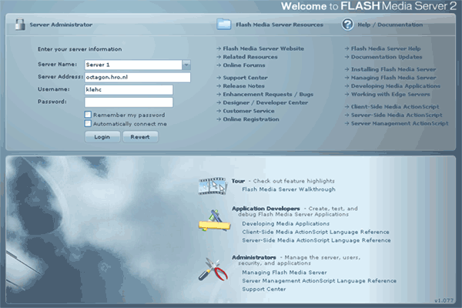
At the time I took this shot I could not log in. The screen will look the same when you are logged-in, but the red block and the warning in the blue field will not be there.
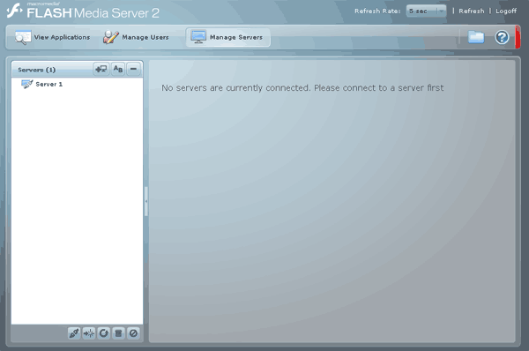
Flash media server is of course not the only one in this field. But it is a big player, with which you can experiment for free and which provide a good on-line Help function. This makes it interesting to play with it.

What can media server do?
Video library
With the media server you can put a video library on-line, in which you search for a video and select it by means of Flash interface to stream it. There is no problem if another visitor of the site requests the video at the same time.
Video Messaging
Next to storing videos it is also possible to make an MSN video connection, with which you could organize a video conference or combine it with chat. That means making your own msn. .
Live Video
You can connect your webcam to the Flash media server, so that every visitor to your site can see the pictures of the webcam. I have understood this concept occurs in many Sophia project concepts. Several webcams and several displays can be dealt with Flash media server.
Rich Internet Applications(RIA)
You can use an RIA for communication purposes, but you could also think of an interactive guide (e.g. a shopping assistant or mounting instructions). The user can make all kinds of choices, with the application producing different films or voice-overs.

Installation (tips and tricks)
Installation is a job for experts, as you should have some experience with Linux and servers. You can download a free version (not for commercial use), unwrap it and put on your server by means of ftp. So far quite easy, but have not finished yet! (download winrar to open the *.tar file)
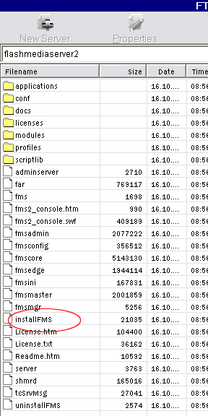
Now you carry out the installation with Linux. Finally, you can not double-click on the installation file with ftp. Here you do not find how to do this.
When you have succeeded, you can get started. Below you find the link for the download. Click 'free developer download'.
http://www.adobe.com/products/flashmediaserver/
You must first register with Adobe. It is my experience that this will not cause any spam to be sent to you.

Where can you find more information?
http://www.adobe.com/devnet/flashmediaserver/
When you get started, you can download the tutorials and the sample files at the following link:
http://www.adobe.com/devnet/flashmediaserver/sample_apps.html
You must copy them in the applications folder on your server, which will use the components that are already present in your media server script library.

Extra: address a local camera
Next to streaming media via the media server, you can always use a webcam that is connected to a laptop. Addressing someone’s own webcam is very simple, as you can see in the example below.
Make a new film and select via Library, top right-hand corner, submenu for a new video object. We did this before in lesson 3. Give this video object a name and take it out of your library by dragging it to the stage. Give your video object on the stage the instance name vLiveCam.
Make a new layer for the actions. In it the following script will be placed:
var my_cam = Camera.get();
vLiveCam.attachVideo(my_cam);
Now you can see the shots of your own camera in your Flash film. There are bound to be more possibilities with camera shots. Inspect the Help function of ActionScript 2.0 library > actionscript classes >.

Author: Roos Groenewegen
Season: Autumn
Lesson number: 07
Date: 16-10-2006
Type of lesson: MME

